Royalty Free Music still has restrictions!

Don’t forget Copyright Issues with music!!
Visit this site for an example of what can happen to you: http://freeplaymusic.com/licensing/termsofuse.php

http://incompetech.com/m/c/royalty-free/
This site lets you right click > “save target as” MP3 sound files
By category, “by feeling” associated with the music, or by keyword.
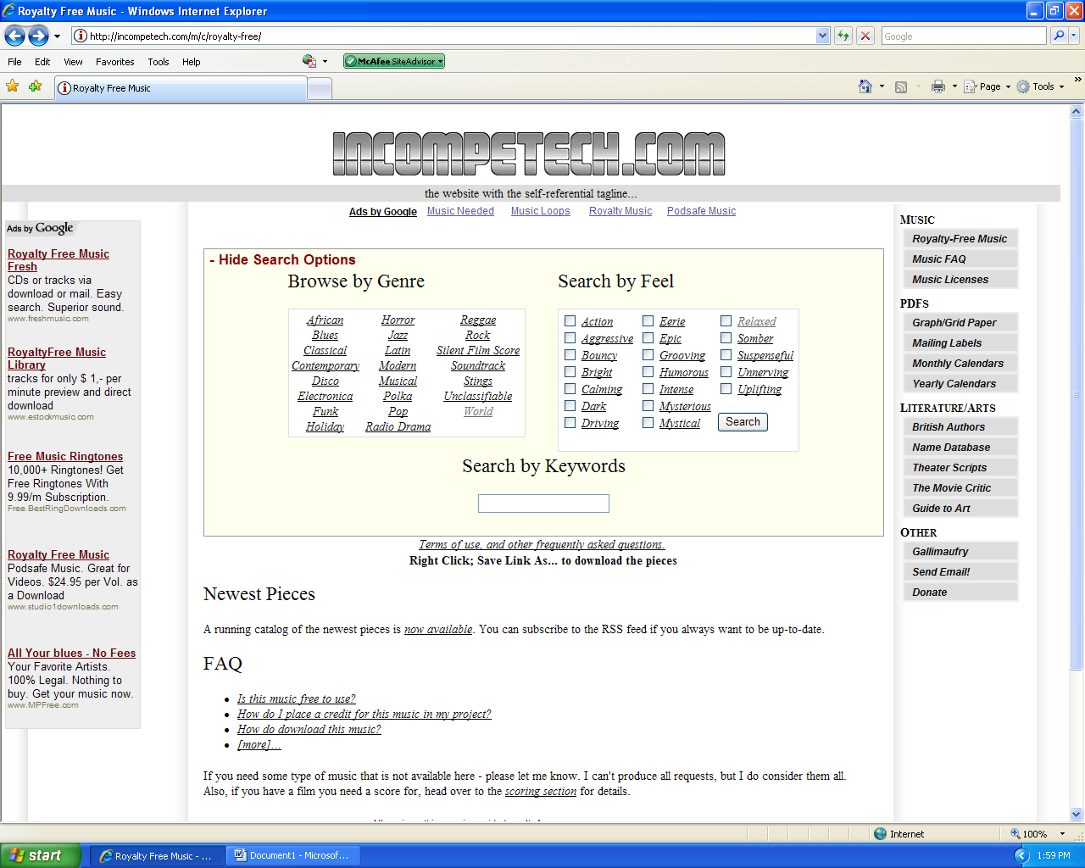
www.royaltyfreemusic.com > use the log in half-way down: chantillyhs – wmk346
This site lets you save some music clips directly (as MP3’s), lets you save some sounds as “movie” files.

http://www.YouTube.com > search for music and/or video; use the Audacity player to record no more than 1 minute of music (30 seconds is really all you are allowed).
Remember to save all music inside the immediate folder where your Moviemaker movie will be saved.

Then insert the music into the movie from that location!

